ECE 568 Assignment 3

Chaoji Zuo

190003416/cz296

Performance evaluation

Figure shows 1 point prediction.

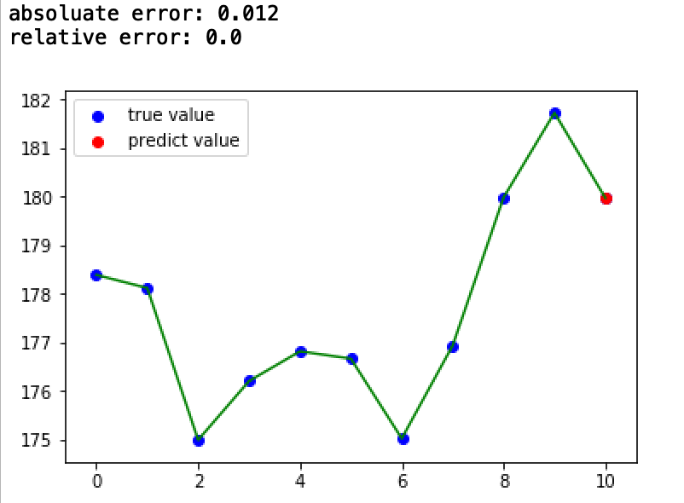

Figure 1

As you can see, the prediction error is very small. The red point is almost on the blue point. The absolute error is just 0.012.

Then I randomly selected 10 days and used their 10 days before data to predict their stock price.

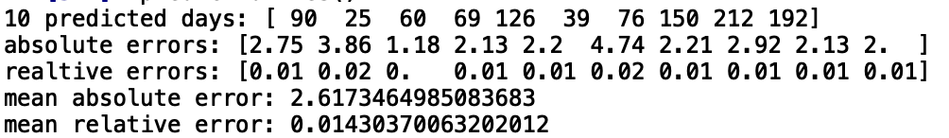

Figure 2

The performance of my program is pretty great. The mean absolute error is just 2.61